Curriculum Vitae
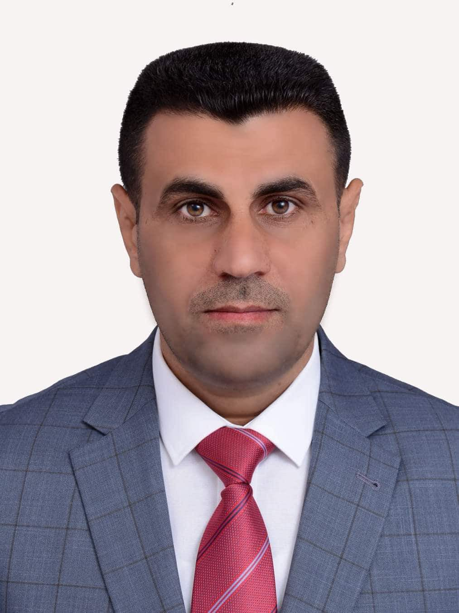

picture

Full Name: Prof. Dr. Abbas Nawar Khait
University : Wasit University
College: Administration and Economics
Date of Birth: 1976
Marital Status: Married
Specialization: Accounting
Academic rank: Professor
Work address: University of Wasit – Kut - Iraq
Phone Number: 009647802059925
E-mail: abnawar@uowasit.edu.iq

Occupation
note | Date obtaining Job | Occupation | NO.
 | From 10/10/2004 to 8/8/2005 | Scientific department decision | 1
 | From 30/9/2006 to 2/10/2007 | Scientific department decision | 2
 | From 2/12/2007 to 23/11/2008 | Assistant Dean for Administrative Affairs | 3
 | From 23/11/2008 to 15/8/2011 | Head of Accounting Department | 4
 | From 11/10/2012 to 15/10/2015 | Assistant Dean for Administrative Affairs | 5
 | From 15/10/2015 to 19/4/2018 | Head of Accounting Department | 6
 | From 12/12/ 2019 | Dean | 7

Academic Qualifications (Cetificates)

Date obtained | University | College | Academic qualification
1999 | Al-Mustansiriyah | Administration and Economics | Bachelor's degree
2002 | Al-Mustansiriyah | Administration and Economics | Master’s degree
2007 | Al-Mustansiriyah | Administration and Economics | Doctorate
---- | ---- | ---- | Other

Academic rank:

Date obtained | Academic rank | NO.
2002 | Assistant lecturer | 1
2007 | Lecturer | 2
2010 | Assistant professor | 3
2015 | Professor | 4

Scientific researches
Date published | Research Title | NO.
2005 | The Effect of Some Contingency Factors on The Use of Managerial Accounting Techninqes | 1
2008 | The role of benchmarking in rationalizing pricing decisions based on target cost | 2
2009 | The role of the Iraqi banking system in combating money laundering | 3
2009 | The efficiency and effectiveness of external audit methods in the electronic operation of accounting information systems | 4
2010 | The role of value engineering in promoting the application of total quality management and achieve the competitive advantages of economic units | 5
2010 | The appropriateness of budget estimates for control and performance evaluation under the adoption of Kaizen | 6
2010 | Integration between TQM and Activities -based Costing | 7
2014 | The strategic role of value engineering in reducing costs and enhancing the competitive advantage of economic units | 8
2014 | The strategic impact of electronic banks on improving the quality of banking services and achieving competitive advantages | 9
2015 | Impact of financial information uncertainty on the quality of management decisions - a proposed model under a hypothetical case study | 10
2015 | Use agile accounting tools to support agile production systems and evaluate the performance of economic units | 11
2015 | Using Signal Theory in Interpreting the Relationship between Environmental Disclosure and Achieving Competitive Advantages (Analytical Study of a Sample of Industrial Companies Listed in the Amman Stock Exchange) | 12
2016 | A proposed model for evaluating the performance of production plans and policies according to the special commissioning method - a study in the light of the International Standard on Auditing (4400). | 13
2016 | Analysis of the relationship between environmental disclosure and financial performance of economic units (analytical study of a sample of industrial companies listed on the Amman Stock Exchange) | 14
2016 | Recognition of hidden quality costs in accordance with international accounting standards | 15
2016 | Analysis of the relationship between quality and costs and its importance to economic units - an analytical theory study | 16
2017 | A proposed model for the application of environmental management accounting in the Iraqi industrial economic units | 17
2017 | A suggested model for auditing environmental performance in economic units | 18
2018 | Study and analysis of environmental strategies for environmental management accounting in the Iraqi economic units | 19
2018 | Responsibility of the external auditor for auditing the environmental performance according to the international auditing standards | 20
2018 | The Effectiveness of Employing Environmental management Accounting Information's for Implement Cleaner Production Strategy | 21
2018 | Using input-output analysis technique to determine and separate environmental costs (applied study in Kufa Cement Plant) | 22
2018 | The use of environmental management accounting information in support of environmental performance | 23
2018 | Use the strategy of small improvement steps to reduce costs | 24
2018 | A proposed model for compatibility between environmental costs and recognition and accounting requirements in accordance with IPSAS | 25
2018 | The importance of environmental management accounting techniques in achieving sustainable development | 26
2019 | Environmental management accounting and its importance in investment decision-making to achieve sustainable development | 27
2019 | The possibility of the application of production technology on time (JIT) to implement an effective manufacturing strategy and achieve customer satisfaction | 28
2018 | The possibility of applying 5s to implement the strategy of effective manufacturing and achieve customer satisfaction - applied research in the General Company for Electrical and Electronic Industries. | 29
2019 | Use sustainability accounting standards in building a green value chain to achieve competitive advantages | 30
2020 | A suggested model for compatibility between sustainability accounting standards and the green value chain | 31
2018 | Use accounting information prepared in accordance with the standards of sustainability accounting to promote sustainable strategic planning | 32
2019 | A proposed model for the integration of environmental and quality costs according to sustainability accounting standards | 33
2019 | A proposed model for the application of four-dimensional concurrent engineering under the strategy of effective manufacturing | 34
2018 | Theoretical framework for the use of simultaneous four-dimensional engineering and achieve competitive advantages | 35
2019 | Use the product life cycle assessment technique to account for environmental costs under sustainability accounting standards | 36
2019 | The use of material flow cost accounting technology in material flow and its reflection in achieving sustainable development | 37
2019 | Using time series by applying the ARIMA model for planning and controlling sales in economic units | 38
2020 | Impact of Ethical Leadership on Team Performance: the Mediating Role of Resolution Efficacy and Individual Performance | 39
2020 | The Role of Green Design In Improving The Dimensions of Sustainability and Achieve Competitive Advantages of Economic Units | 40
2020 | Integration Cost Accounting Flow of Materials and Green Design to Achieve A Sustainable Competitive Advantage | 41
2020 | Theoretical Framework for Adding The Sustainability Perspective to The Balanced Scorecard and its Reflection in the Economic Unit Strategy | 42
2020 | A Proposed Model to Use Performance Focused Activity Based Costing in Application Sustainable Balanced Scorecard | 43
2020 | The theory of constraints and value engineering conforms to sustainability accounting standards by making it a strategic dimension of cost management and improving product value | 44
2020 | A suggested model for using value engineering to implement the theory of constraints in the Iraqi economic environment according to the criteria of sustainability accounting | 45

Published and Translated Books:
Published Date | Book Title | No. النشر
---- | ---- | 1

Number of Theses
Number | Supervision | NO.
1 | Higher diploma | 1
15 | Masters | 2
4 | Ph.D | 3

Academic Conference, seminars and workshops attended
Date | place | Kind of participation | Title | NO.
 |  |  |  | 1
 |  |  |  | 2
 |  |  |  | 3
 |  |  |  | 4
 |  |  |  | 5

Course Taught
( Master, PhD)Postgraduate | Undergraduate | NO.
Cost Accounting / Master stage | Managerial Accounting / fourth stage | 1
Managerial Accounting / Master stage | Accounting Theory / fourth stage | 2
Advanced Cost Accounting / Master stage | Cost Accounting / third stage | 3
Managerial Decisions / Higher Diploma Stage | Audit and Control / third stage | 4
 | Intermediate Accounting / second stage | 5
 | Principles of Accounting / first stag | 6

Awards, Certificates and Letters of appreciation
Date obtained | Institution Awarded | Awards, Certificates and Letters of appreciation | NO.

Languages skills
Level ( Beginner,Inermediate,Advance ) | Language | NO.
Advance | Arabic | 1
Intermediate | English | 2

